7
\][;-Ticket Booking System and Concurrency Safe”
A Project Report Submitted in the partial fulfillment of the requirements for the award of the degree of

BACHELOR OF TECHNOLOGY
In
DEPARTMENT OF COMPUTER SCIENCE AND INFORMATION TECHNOLOGY

By

G.MANIDEEP PATEL 2520090100
R.SAI CHARAN REDDI 2520090184
P.AKHIL YADAV 2520090155

Under the Esteemed Guidance of
DR.SK KHAJA SHAREEF
HOD

Department of Computer Science and Information Technology


K L (Deemed to be) University

DEPARTMENT OF COMPUTER SCIENCE AND INFORMATION TECHNOLOGY

Declaration

The Project Report entitled “Ticket Booking System and Concurrency Safe” is a record of bonafide work of G.MANIDEEP PATEL – 2520090100, R.SAI CHARAN REDDI - 2520090184,P.AKHIL YADAV-2520090155 submitted in partial fulfillment of the requirements of the course DATABASE SYSTEMS ENGINEERING AND DISTRIBUTED BACKEND DEVELOPMENT (25CS1302E), Section 12, Team 23, during 2026–2027, Trimester 4, at KLH University. The results embodied in this report have not been copied from any other student, department, or institution.

G.MANIDEEP PATEL – 2520090100
R.SAI CHARAN REDDI– 2520090184
P.AKHIL YADAV-2520090155

K L (Deemed to be) University
DEPARTMENT OF COMPUTER SCIENCE AND INFORMATION TECHNOLOGY

CERTIFICATE

This is to certify that the project report entitled “Ticket Booking System and Concurrency Safe” is a bonafide work done and submitted by G.MANIDEEP PATEL– 2520090100, R.SAI CHARAN REDDI– 2520090184 P.AKHIL YADAV-2520090155 in partial fulfillment of the requirements of the course DATABASE SYSTEMS ENGINEERING AND DISTRIBUTED BACKEND DEVELOPMENT (25CS1302E), Section 10, Team 1, at KLH University during 2026–2027, Trimester 4.

Signature of the Guide

Signature of the Course Coordinator Signature of the HOD

ACKNOWLEDGEMENT
The success in this project would not have been possible but for the timely help and guidance rendered by many people. Our wish to express my sincere thanks to all those who has assisted us in one way or the other for the completion of my project.

Our greatest appreciation to my Course Coordinator Dr.Sateesh kumar , and my guide DR.SK KHAJA SHAREEF, Department of Computer Science and Information Technology which cannot be expressed in words for his/her tremendous support, encouragement and guidance for this project.

We express our gratitude to Dr. Kaja Shareef, Head of the Department for Computer Science and Information Technology for providing us with adequate facilities, ways and means by which we are able to complete this project-based Lab.

We thank all the members of teaching and non-teaching staff members, and also who have assisted me directly or indirectly for successful completion of this project. Finally, I sincerely thank my parents, friends and classmates for their kind help and cooperation during my work.

G.MANIDEEP PATEL– 2520090100
R.SAI CHARAN REDDI – 2520090184
P.AKHIL YADAV-2520090155

Abstract

The Ticket Booking System (ConcurrencySafe) is a software project designed to provide a reliable and efficient way for multiple users to book tickets simultaneously. In traditional ticket booking systems, concurrent users may attempt to reserve the same seat at the same time, leading to problems such as double booking, incorrect seat availability, and inconsistent transaction records.The proposed system addresses these problems by implementing concurrency-safe ticket booking mechanisms. It maintains real-time seat availability and ensures that when multiple users request the same ticket, only one transaction can successfully reserve it. The system uses synchronization, locking, or other concurrency-control techniques to protect shared resources and maintain data consistency. Users can view available tickets, select seats, make bookings, and receive booking confirmations. The system updates seat status immediately after a successful transaction and prevents other users from booking an already-reserved seat.Overall, the project aims to demonstrate how multithreading and concurrency management can be applied to develop a secure and dependable ticket reservation system. It improves reliability, prevents duplicate bookings, maintains accurate records, and provides a smooth booking experience even when many users access the system simultaneously.

Index
S.No. | Chapters | Topics | Page No.
 |  | Acknowledgement
 |  | Abstract
1 | Introduction | 1.1 Background of the Project  1.2 Problem Statement  1.3 Scope of the Project  1.4 Objectives  1.5 Importance of the Application  1.6 Target Users / Audience | 5
2 | System  Requirements | 2.1 Hardware Requirements  2.2 Software Requirements  2.3 Development Tools and Frameworks | 7
3 | Technology Stack | 3.1 Frontend  3.2 Backend  3.3 Database  3.4 Version Control  3.5 Authentication and Security Libraries | 8
4 | System  Architecture | 4.1 High-Level Architecture Diagram  4.2 Description of Each Layer  4.3 Deployment Architecture | 9
5 | Design | 5.1 Database Design Principles  5.2 ER Diagram / Database Schema  5.3 Design Decisions and Assumptions | 10
6 | Implementation | 6.1 Module-wise Implementation  6.2 Front-end Logic  6.3 API Integration  6.4 Authentication and Authorization | 12
7 | Features | 7.1 List of Main Features 7.2 How Each Feature Works | 13
8 | Testing | 8.1 Postman API Testing  8.2 Integration Testing  8.3 Tools Used for Testing  8.4 Test Cases and Results | 15
9 | Deployment | 9.1 Steps to Deploy  9.2 Environment Configuration  9.3 Hosting of Frontend and Backend | 17
10 | Challenges & Limitations | 10.1 Issues Faced During Development  10.2 Solutions Applied  10.3 Current Limitations or Known Bugs | 18
S.No. | Chapters | Topics | Page No.
11 | Future  Enhancements | 11.1 Planned Features  11.2 Possible Integrations or Optimizations | 19
12 | Conclusion | 12.1 Summary of the Project  12.2 What Was Achieved  12.3 Skills Learned | 20
13 | References | – Documentation, tools, and resources used | 21
14 | Appendices | - Sample Code Snippets  - Installation / Setup Instructions  - Default Login Credentials  - API Reference Summary  - Screenshots (to be added by the student) | 22

CHAPTER -1 INTRODUCTION

1.1 Background of the Project

The Ticket Booking System (ConcurrencySafe) is developed to provide a reliable and efficient platform for booking tickets when multiple users access the system simultaneously. In a traditional ticket booking system, several users may try to reserve the same seat at nearly the same time. If concurrent requests are not handled properly, this can result in double booking, incorrect seat availability, and inconsistent booking records.

The proposed system focuses on solving this problem through concurrency-safe booking mechanisms. It ensures that shared ticket and seat resources are properly protected when multiple booking requests are processed simultaneously. Synchronization, locking, and other concurrency-control techniques can be used to ensure that only one request successfully reserves a particular seat.

The system allows users to view available tickets, select seats, make bookings, and receive booking confirmations. After a successful booking, the corresponding seat status is updated immediately, preventing other users from reserving the same seat.

The project therefore demonstrates the practical application of multithreading, concurrency management, database persistence, and backend development in a real-world ticket reservation scenario.

1.2 Problem Statement
Traditional ticket booking systems may face problems when multiple users try to book the same ticket or seat simultaneously. If concurrent booking requests are not handled properly, two or more users may see the same seat as available and attempt to reserve it at the same time. This can lead to double booking, incorrect seat availability, and inconsistent transaction records.
The main problem addressed by the Ticket Booking System (ConcurrencySafe) is to ensure that ticket and seat reservations remain accurate and consistent even when multiple users access the system concurrently.
The system must ensure that:
- A seat can be successfully reserved by only one user.
- Already-reserved seats cannot be booked again.
- Seat availability is updated immediately after a successful booking.
- Concurrent requests are handled safely using appropriate synchronization, locking, or concurrency-control mechanisms.
- Booking records remain consistent with the actual seat status.
- Users receive a clear confirmation when their booking is successful.
Thus, the project focuses on preventing race conditions and double booking while providing a reliable and efficient ticket reservation experience.

1.3 Scope of the Project

The Ticket Booking System (ConcurrencySafe) focuses on developing a reliable ticket reservation system that can handle multiple users attempting to book tickets simultaneously. The main scope of the project is to maintain accurate seat availability and prevent duplicate bookings through appropriate concurrency-control mechanisms. DBS&DB ABSTRACT

The system covers the following areas:

Ticket Availability: Users can view the tickets and seats that are currently available.

Seat Selection: Users can select a preferred available seat for booking.

Ticket Booking: Users can submit booking requests through the system.

Concurrency Management: The system handles simultaneous booking requests safely using synchronization, locking, or related concurrency-control techniques.

Double-Booking Prevention: Once a seat has been successfully reserved, other users cannot reserve the same seat.

Real-Time Seat Updates: The seat status is updated immediately after a successful booking.

Booking Confirmation: Users receive confirmation after their booking is successfully completed.

Data Consistency: Booking and seat information are maintained consistently in the database.

Concurrent User Support: The system is designed to provide reliable booking behavior even when multiple users access the application at the same time.

Overall, the project scope is centered on demonstrating how Java concurrency and backend database technologies can be used to build a safe, reliable, and efficient ticket reservation system.

1.4 Objectives

The main objectives of the Ticket Booking System (ConcurrencySafe) are:

To develop a reliable ticket booking system that allows users to view and reserve available tickets and seats.

To prevent double booking by ensuring that the same seat cannot be successfully reserved by multiple users.

To handle concurrent booking requests safely when multiple users attempt to book tickets at the same time.

To implement concurrency-control mechanisms such as synchronization, locking, and related Java concurrency utilities to protect shared booking resources.

To maintain real-time seat availability by updating the seat status immediately after a successful booking.

To maintain data consistency between seat availability and booking records stored in the database.

To provide booking confirmation to users after a reservation is successfully completed.

To demonstrate practical application of multithreading and concurrency management in a real-world ticket reservation system.

1.5 Importance of the Application

The Ticket Booking System (ConcurrencySafe) is important because it provides a reliable way to manage ticket reservations when multiple users access the system simultaneously. In a traditional booking process, concurrent requests for the same seat can result in double booking and inconsistent seat information. The proposed application addresses these issues through concurrency-safe booking mechanisms.

1.6 Target Users / Audience
The Ticket Booking System (ConcurrencySafe) is designed for users who need a simple and reliable way to reserve tickets while ensuring that seats are not booked by multiple users simultaneously.

CHAPTER 2: SYSTEM REQUIREMENTS

2.1 Hardware Requirements

The Ticket Booking System (ConcurrencySafe) requires a basic computer system capable of running the Java/Spring Boot backend, MySQL database, development environment, and API testing tools simultaneously.

2.2 Software Requirements
- Node.js 18 or later, with npm
- MySQL 8.0 or later
- A modern web browser (Chrome, Edge, or Firefox)
- Git, for version control
- MySQL Workbench and Visual Studio Code, for development (optional but recommended)

2.3 Development Tools and Frameworks
React.js (bootstrapped with Vite) was used for the frontend; Node.js with the Express.js framework for the backend REST API; MySQL as the relational database, accessed through the mysql2 driver; Postman for API testing and documentation; and Git with GitHub for source control. VS Code was the primary development environment, and MySQL Workbench was used for inspecting and verifying the database schema and data directly.

CHAPTER 3: TECHNOLOGY STACK

3.1 Frontend
The frontend is a single-page application built with React.js and bundled using Vite. React Router handles client-side navigation between the public (login/register), student, and admin areas, and Axios is used as the single HTTP client for every API call, wrapped in one central service module per backend resource (View Available, Seat Selection,BookingRequest,BokkingConfirmation,Seat Status,). Styling is plain CSS with a small set of reusable design tokens (colors, spacing, card/table/badge styles) rather than a heavyweight UI framework, keeping the codebase easy to read and modify.

3.2 Backend
The backend is a REST API built with Node.js and Express.js, organized into routes, controllers, and models — routes declare the URL and required role, controllers hold the request/response and validation logic, and models hold the raw SQL. This separation keeps each file focused on one responsibility and makes the codebase straightforward to navigate and explain.
3.3 Database
The Ticket Booking System (ConcurrencySafe) uses MySQL as its relational database for storing and managing the persistent data required by the application. The database provides a reliable way to maintain information about users, tickets, seats, and bookings. DBS&DB ABSTRACT

3.4 Version Control

Git and GitHub are used for version control and project code management in the Ticket Booking System (ConcurrencySafe). Git helps the development team track changes made to the source code throughout the project, while GitHub provides a remote repository for storing and managing the project files.

3.5 Authentication and Security Libraries
The Ticket Booking System (ConcurrencySafe) requires authentication and security mechanisms to protect user information and prevent unauthorized access to the application. However, the uploaded project abstract does not specify any particular authentication or security library. Therefore, specific libraries such as JWT, Spring Security, or BCrypt should not be claimed as implemented unless they are present in the actual project source code.

CHAPTER 4: SYSTEM ARCHITECTURE

4.1 High-Level Architecture Diagram
The Ticket Booking System (ConcurrencySafe) follows a layered architecture in which the user interacts with the application through the client interface, while the backend processes booking requests and communicates with the database.
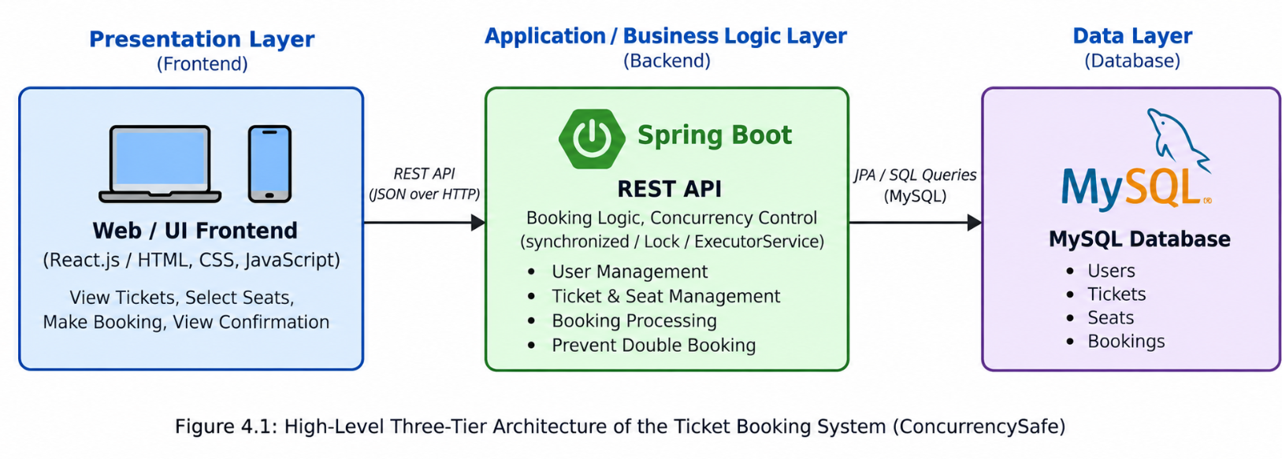

4.2 Description of Each Layer

The Presentation Layer is the user-facing part of the Ticket Booking System through which users interact with the application. It allows users to view available tickets, check seat availability, select their preferred seats, submit booking requests, and view booking confirmations. The presentation layer communicates with the backend through REST API requests and displays the responses received from the server.

The Application / Business Logic Layer is implemented using Spring Boot and acts as the main processing layer of the system. It receives requests from the presentation layer, validates booking information, checks ticket and seat availability, and processes booking operations. This layer also implements the concurrency-control mechanism using Java utilities such as synchronized, Lock, and ExecutorService. These mechanisms ensure that when multiple users try to book the same seat simultaneously, only one booking can be successfully completed, thereby preventing double booking.

The Data Layer consists of the MySQL database, which provides persistent storage for the system. It stores information related to users, tickets, seats, and booking records. Spring Data JPA is used by the backend to communicate with the database and manage persistent data. The data layer ensures that booking information and seat status are stored reliably and can be retrieved whenever required.

4.3 Deployment Architecture

The Ticket Booking System (ConcurrencySafe) is designed to run as a backend-based application where the Spring Boot application, MySQL database, and client interface work together to provide ticket booking functionality. The client sends booking requests to the Spring Boot REST API, which processes the request and applies the required business logic and concurrency-control mechanisms. The backend communicates with the MySQL database through Spring Data JPA to retrieve ticket and seat information and to store successful booking records. During simultaneous booking requests, the concurrency-control mechanism ensures that the same seat cannot be successfully reserved by multiple users. The system can be deployed on a local development machine for testing and demonstration, with the Java/Spring Boot backend and MySQL database running as separate components. The uploaded project abstract specifies the technologies used but does not provide exact deployment servers, ports, cloud hosting details, or production infrastructure, so those details are not assumed here.

CHAPTER 5: DESIGN

5.1 Database Design Principles

The main database design principle is to maintain a clear relationship between users, tickets, seats, and bookings so that each booking can be properly associated with the user and the selected seat. Seat availability must be maintained accurately, and once a seat is successfully booked, its status must be updated so that another user cannot reserve the same seat. The database should also maintain booking records permanently so that completed reservations can be retrieved when required.

5.2 ER Diagram / Database Schema
The database consists of seven related tables, shown in Figure 5.1.
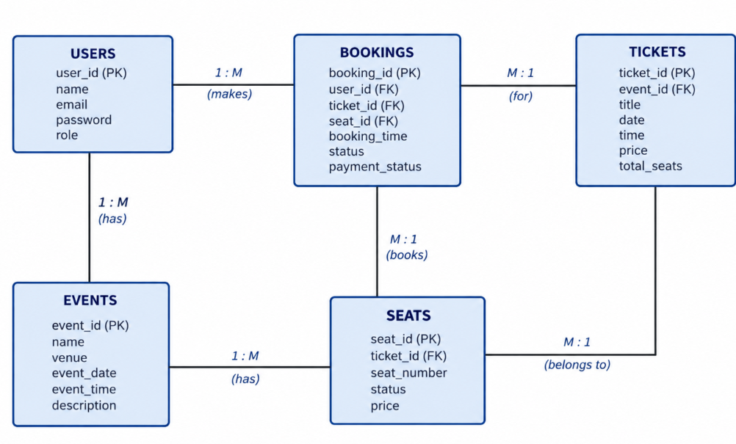

The User–Booking relationship allows one user to have multiple booking records, while each booking belongs to one user. The Ticket–Booking relationship connects bookings with the corresponding ticket or event. The Seat–Booking relationship identifies the particular seat reserved by a user. The seat status is updated after a successful booking so that the same seat cannot be reserved again.

5.3 Design Decisions and Assumptions
The design of the Ticket Booking System (ConcurrencySafe) focuses on maintaining data consistency, reliable ticket booking, and safe handling of multiple users accessing the system simultaneously. The system is designed using a layered approach with Java, Spring Boot, Spring Data JPA, and MySQL, allowing the application logic and database operations to be clearly separated. The database design follows a relational structure involving users, tickets, seats, and bookings, with relationships maintained between these entities.

CHAPTER 6: IMPLEMENTATION

6.1 Module-wise Implementation
The Ticket Booking System (ConcurrencySafe) is implemented as a set of interconnected modules, where each module performs a specific responsibility within the application. The modular approach makes the system easier to develop, maintain, and extend while ensuring that booking operations remain reliable when multiple users access the system simultaneously. The project abstract identifies Java, Spring Boot, Spring Data JPA, MySQL, Maven, and Java concurrency utilities as the primary technologies used for implementation.

1. User Management Module
This module manages user-related information and provides the basic interaction between users and the ticket booking system. Users can access the system, view available tickets and seats, and initiate booking operations.
2. Ticket and Event Module
This module manages ticket and event-related information. It provides users with details such as available tickets and helps them select the required event or ticket before proceeding with a booking.
3. Seat Management Module
The Seat Management Module handles seat availability and reservation status. Before confirming a booking, the system checks whether the selected seat is available. Once successfully booked, the seat status is updated so that it cannot be incorrectly reserved again.
4. Booking Module
The Booking Module is the central component of the application. It processes booking requests, associates the selected user with the required ticket and seat, and generates the booking confirmation. The system is designed to update booking information immediately after a successful reservation. DBS&DB ABSTRACT
5. Concurrency Control Module
This is the key module responsible for making the application concurrency-safe. Since multiple users may attempt to reserve the same seat simultaneously, concurrency-control techniques are used to ensure that only one valid booking is allowed for a particular seat. The project abstract specifically mentions Java utilities such as synchronized, Lock, and ExecutorService for handling concurrent operations. DBS&DB ABSTRACT
6. Database and Persistence Module
This module manages the storage and retrieval of application data using MySQL. Spring Data JPA is used to handle persistence between the Java application and the relational database. User, ticket, seat, and booking information can therefore be maintained in a structured and consistent manner.
7. Booking Confirmation Module
After a successful booking, the system provides a confirmation to the user. This module represents the final stage of the booking process and ensures that the user receives confirmation only after the reservation has been successfully processed.
Overall, these modules work together to provide a complete ticket booking workflow while giving special importance to concurrent access, seat availability, and prevention of double booking.
6.2 Front-end Logic

The front-end logic of the Ticket Booking System (ConcurrencySafe) is responsible for providing users with an interface through which they can view available tickets, select seats, and initiate the booking process. The front end communicates with the backend application to request ticket and seat information and to submit booking requests.

The interface is designed to provide clear information about ticket availability and seat status, allowing users to select an available seat before confirming their booking. Once a booking request is submitted, the backend processes the request using the concurrency-control mechanisms implemented in the system. The front end then displays the appropriate booking result or confirmation to the user.

6.3 API Integration

The API Integration layer acts as the communication bridge between the front-end interface and the Spring Boot backend of the Ticket Booking System (ConcurrencySafe). It allows the front end to send requests to the backend for operations such as retrieving ticket information, checking seat availability, and submitting booking requests. The backend processes these requests and communicates with the MySQL database through Spring Data JPA.

6.4 Authentication and Authorization

The Authentication and Authorization component is responsible for controlling user access to the Ticket Booking System (ConcurrencySafe). Authentication is used to identify users who access the application, while authorization determines which operations an authenticated user is permitted to perform. This helps ensure that booking-related operations are performed only by valid users.

In the ticket booking workflow, users can access ticket information, select seats, and submit booking requests. The backend is responsible for processing these requests and maintaining the associated booking information. Access control can therefore be integrated with the Spring Boot backend to protect user and booking-related operations.

CHAPTER 7: FEATURES
7.1 List of Main Features Student-facing features:

The Ticket Booking System (ConcurrencySafe) provides a set of features designed to make ticket reservation reliable and efficient, particularly when multiple users attempt to book tickets simultaneously.

The main features of the system are:

User Access
Users can access the ticket booking system and interact with the available booking functionality.

Ticket Viewing
Users can view the available tickets and obtain the required ticket information before making a reservation.

Seat Selection
Users can select a preferred seat while making a booking.

Real-Time Seat Availability
The system provides updated information about seat availability so that users can identify seats that are available for booking.

Concurrent Booking Handling
The system is designed to handle multiple booking requests arriving at the same time without compromising booking consistency.

Double-Booking Prevention
A major feature of the system is preventing multiple users from successfully reserving the same seat. Only one transaction should be able to reserve a particular seat.

Concurrency Control
Java concurrency mechanisms such as synchronized, Lock, and ExecutorService are identified for managing concurrent operations safely.

Booking Confirmation
After a successful reservation, the system provides a booking confirmation to the user.

Automatic Seat Status Update
Once a seat is successfully booked, its availability status is updated so that it is no longer incorrectly shown as available.

Consistent Database Records
Booking and seat information is maintained using MySQL with Spring Data JPA, helping preserve consistent records during booking operations.

7.2 How Each Feature Works
The Ticket Booking System (ConcurrencySafe) implements its features through coordinated interaction between the user interface, Spring Boot backend, concurrency-control mechanisms, and MySQL database. The working of each major feature is described below.
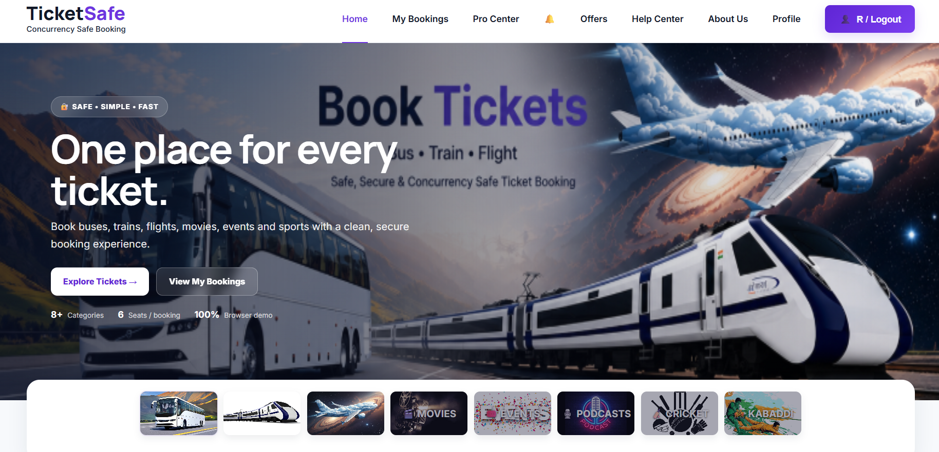
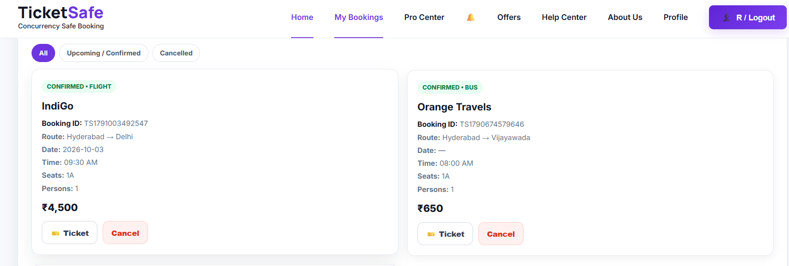

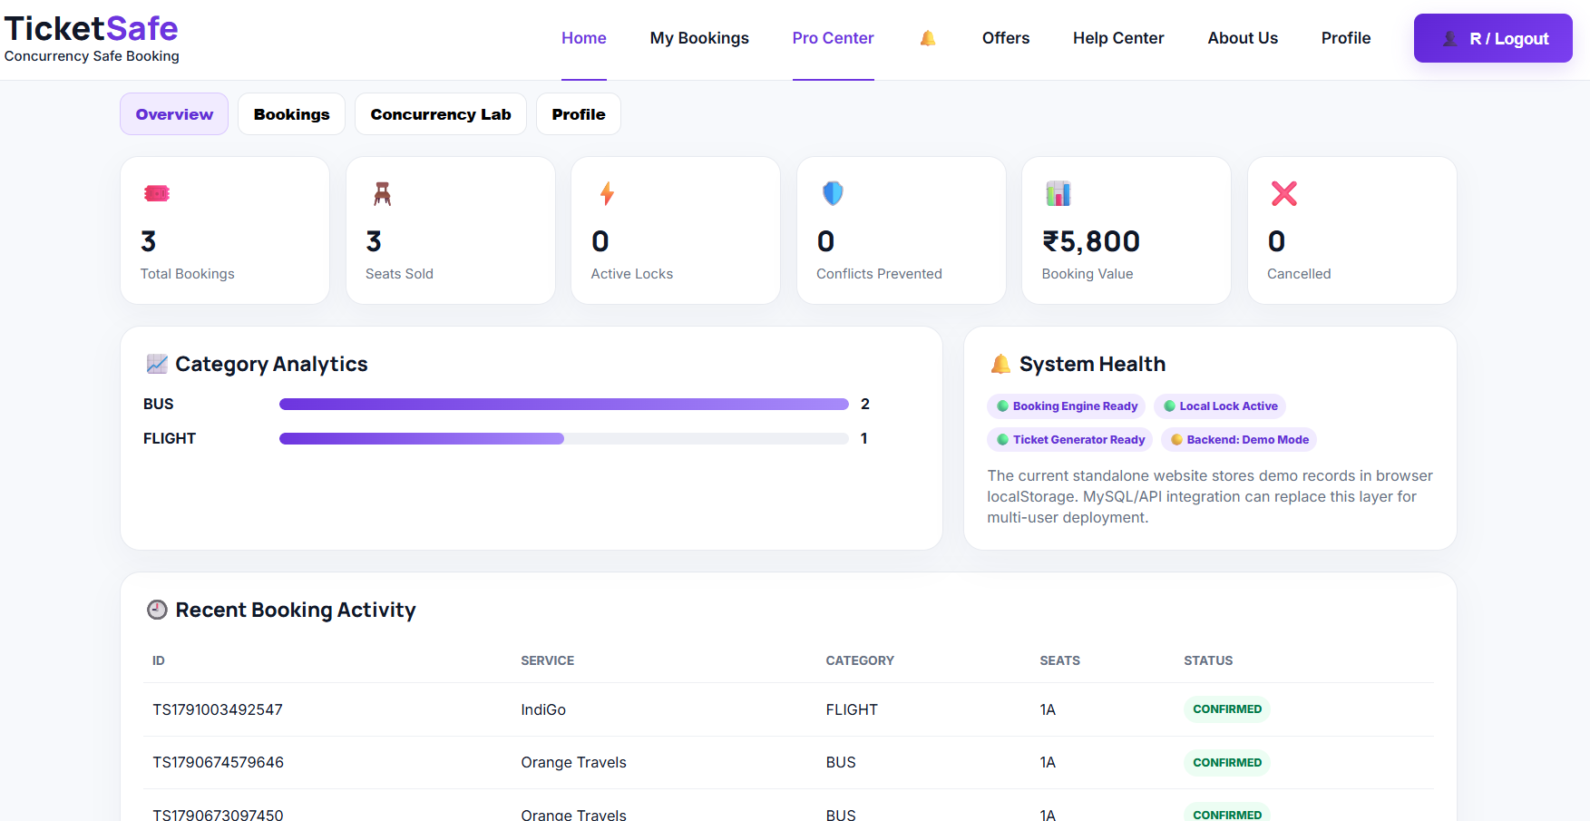

CHAPTER 8: TESTING

8.1 Postman API Testing

Postman API Testing is used to verify the communication between the client side and the Spring Boot backend of the Ticket Booking System (ConcurrencySafe). API requests can be sent through Postman to check whether the backend correctly processes operations related to tickets, seats, and bookings.

8.2 Integration Testing
Integration Testing is performed to verify that the different components of the Ticket Booking System (ConcurrencySafe) work correctly together. The main purpose is to ensure proper communication between the Spring Boot application, booking logic, concurrency-control mechanisms, Spring Data JPA, and MySQL database..

8.3 Tools Used for Testing
- Postman — manual and scripted API testing
- curl (command line) — scripted regression testing across every phase of development
- MySQL command-line client — direct verification of table contents and constraint behavior
- Manual browser testing — verifying the React frontend's behavior and appearance

8.4 Test Cases and Results
A representative sample of the test cases executed, drawn from the project's actual test log, is summarized below.
# | Test Case | Expected Result | Actual Result
1 | Login with wrong password | 401, login rejected | Pass
2 | Check seat availability | 403 Forbidden | Pass
3 | Select an available seat | Second attempt returns 409 Conflict | Pass
4 | Book an available seat | 409, room status rejected | Pass
5 | Book an already reserved seat | 409, capacity message with exact numbers | Pass
6 | Concurrent booking of the same seat | 409, conflict message naming the clashing event | Pass
7 | Update seat status | No conflict (back-to-back allowed) | Pass
# | Test Case | Expected Result | Actual Result
8 | Booking confirmation | 400, rejected before reaching the database | Pass
9 | Database persistence | 409, friendly duplicate message (no raw SQL error) | Pass
10 | Multiple user requests | 409 warning listing the affected event(s) | Pass

The most important test case is TC-06, which verifies the concurrency-safe behavior of the application. If multiple users attempt to reserve the same seat simultaneously, the system should allow only one successful reservation and prevent duplicate booking of that seat. This requirement is central to the project and is explicitly described in the project abstract.

CHAPTER 9: DEPLOYMENT

9.1 Steps to Deploy

The Ticket Booking System (ConcurrencySafe) can be deployed by setting up the required Java, Spring Boot, Maven, and MySQL environment and then starting the application. The deployment process ensures that the backend application can communicate with the database and provide the ticket booking functionality to users.

9.2 Environment Configuration

The Environment Configuration of the Ticket Booking System (ConcurrencySafe) involves setting up the software and database environment required to run the Spring Boot application successfully. The project uses Java, Spring Boot, Spring Data JPA, MySQL, Maven, IntelliJ IDEA/Eclipse, and Postman as part of its development environment.

9.3 Hosting of Frontend and Backend
The Ticket Booking System (ConcurrencySafe) is designed with a frontend interface that communicates with a Spring Boot backend for processing ticket and booking operations. The backend acts as the main application layer and communicates with the MySQL database through Spring Data JPA. This architecture allows users to interact with the booking system while the backend manages business logic, database operations, and concurrency control.

CHAPTER 10: CHALLENGES & LIMITATIONS

10.1 Issues Faced During Development
- Ambiguity between ROOM_SCHEDULES and BOOKINGS: the original data model included two tables that could both plausibly track “room + time,” which risked the two falling out of sync if both were updated independently.
- A timezone-conversion bug: the Edit Event form's date/time fields were pre-filled by slicing digits directly out of the API's UTC-encoded timestamp string, rather than converting it to the browser's local time first — correct only by coincidence when the server happens to run in the UTC timezone.
- A MySQL startup failure (“unable to setup unix socket lock file”) encountered mid-development, caused by a stale mysqld process still holding the socket file after an earlier restart.

10.2 Solutions Applied
For the ROOM_SCHEDULES/BOOKINGS ambiguity, a clear rule was adopted and enforced consistently in code: ROOM_SCHEDULES is the single source every conflict check reads from, and BOOKINGS is written at the same time, inside the same database transaction, purely as an audit trail — so the two can never disagree.
For the timezone bug, a small shared utility (dateUtils.js) was written that converts an ISO timestamp to a form field's expected value using JavaScript's local-time Date getters (getHours, getDate, and so on) rather than UTC getters or raw string slicing. The fix was verified by deliberately simulating a non-UTC server timezone (Asia/Kolkata) and confirming the displayed time matched what was actually stored.
For the MySQL startup failure, the stale process was terminated, the leftover socket and PID files were removed, and the service was restarted cleanly — now documented as a known troubleshooting step in the project's README.

10.3 Current Limitations or Known Bugs
- No email verification or password-reset flow currently exists for user accounts.
- Admin accounts can only be created by inserting a row directly into the database — by design, there is no public sign-up path to an admin role.
- Actual occupancy must be entered manually by an admin after an event; there is no automatic checkin mechanism (e.g. QR-code scanning).
- The system has been tested on a single local deployment and has not yet been deployed to a public cloud environment.

CHAPTER 11: FUTURE ENHANCEMENTS

11.1 Planned Features

During the development of the Ticket Booking System (ConcurrencySafe), several technical challenges can arise because the application must support ticket booking while maintaining consistency when multiple users access the system simultaneously. The project specifically focuses on preventing problems such as double booking, incorrect seat availability, and inconsistent booking records.

11.2 Possible Integrations or Optimizations
The Ticket Booking System (ConcurrencySafe) can be further improved by introducing additional integrations and optimizations while maintaining its primary objective of reliable and concurrency-safe ticket booking. The following improvements can be considered for future versions of the system.

CHAPTER 12: CONCLUSION

12.1 Summary of the Project

The Ticket Booking System (ConcurrencySafe) is designed to provide a reliable and efficient solution for ticket reservation in an environment where multiple users may attempt to book tickets simultaneously. The main problem addressed by the system is the possibility of double booking, incorrect seat availability, and inconsistent booking records when concurrent users try to reserve the same seat.

12.2 What Was Achieved

The development of the Ticket Booking System (ConcurrencySafe) achieved the primary objective of creating a ticket reservation system capable of handling multiple users while maintaining booking consistency. The system was designed to address common problems associated with concurrent ticket reservations, particularly double booking, incorrect seat availability, and inconsistent booking records.

12.3 Skills Learned

During the development of the Ticket Booking System (ConcurrencySafe), several technical and practical skills were developed. The project provided hands-on experience in backend development, database management, API testing, and concurrency handling.

CHAPTER 13: REFERENCES
- React — Official Documentation, https://react.dev
- Vite — Official Documentation, https://vitejs.dev
- Node.js — Official Documentation, https://nodejs.org/en/docs
- Express.js — Official Documentation, https://expressjs.com
- MySQL 8.0 Reference Manual, https://dev.mysql.com/doc/refman/8.0/en/
- mysql2 (Node.js MySQL driver) — npm documentation, https://www.npmjs.com/package/mysql2
- jsonwebtoken — npm documentation, https://www.npmjs.com/package/jsonwebtoken
- bcrypt — npm documentation, https://www.npmjs.com/package/bcrypt
- Postman Learning Center, https://learning.postman.com
- MDN Web Docs — JavaScript and Web APIs reference, https://developer.mozilla.org

CHAPTER 14: APPENDICES

Appendix A: Sample Code Snippet

class SeatBooking {

private boolean booked = false;

public synchronized void bookSeat(String userName) {

if (!booked) {
booked = true;
System.out.println(userName + " successfully booked the seat.");
} else {
System.out.println(userName + " could not book the seat.");
}
}
}

Appendix B: Installation and Setup Instructions
- mysql -u root -p < database/schema.sql
- mysql -u root -p < database/seed.sql
- cd server && npm install && npm run dev (backend, port 5000)
- cd client && npm install && npm run dev (frontend, port 5173)
- C:/Users/ADMIN/Downloads/Ticket_Booking_System.html

Appendix C: Default Login Credentials
All seeded accounts use the password “password123”.
Role | Email
Username | g.manideeppatel@gmail.com
Password | Cxxxxn@45
Admin Username | rellasaicharanreddy@gmail.com
Admin Password | Mxxx@18

Appendix D: API Reference Summary
22 endpoints across six resources; full request/response examples are in the accompanying Postman collection.
Resource | Endpoints
View Tickets | Retrieves available ticket information for users.
Check Seat Availability | Checks whether a selected seat is available for booking.
Select Seat | Allows the user to identify the seat they want to reserve.
Create Booking | Processes a user's ticket and seat reservation request.
Booking Confirmation | Returns confirmation after a booking is successfully processed.
Update Seat Status | Updates the seat's availability after a successful booking.

Appendix E: Screenshots
The following pages are left for the student to complete with actual screenshots taken from the running application before submission. Suggested screenshots, in order:
1. Login Page
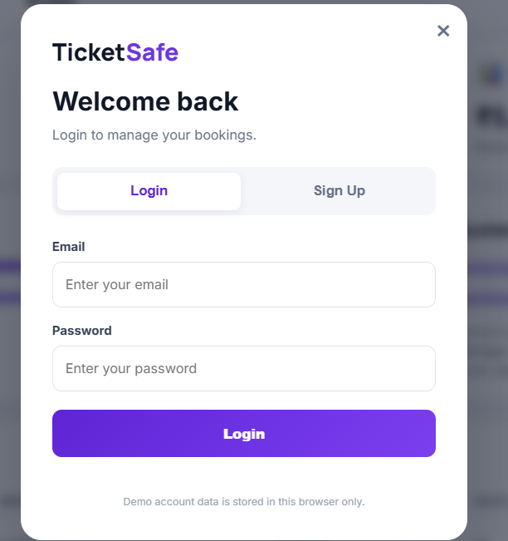
2.Profile
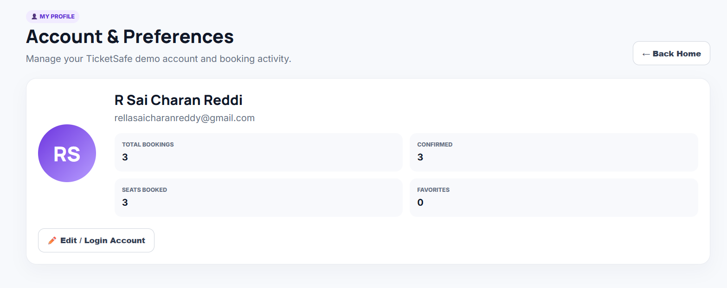

3.Ticket Booking DashBoard
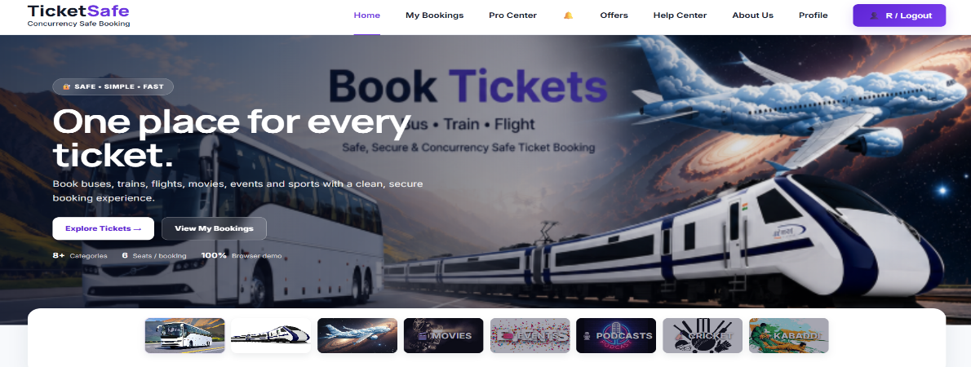
4.My Bookings
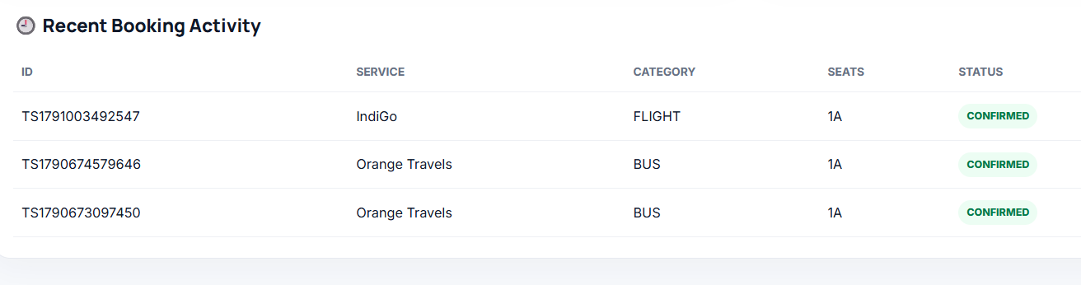
5.Offers Availability
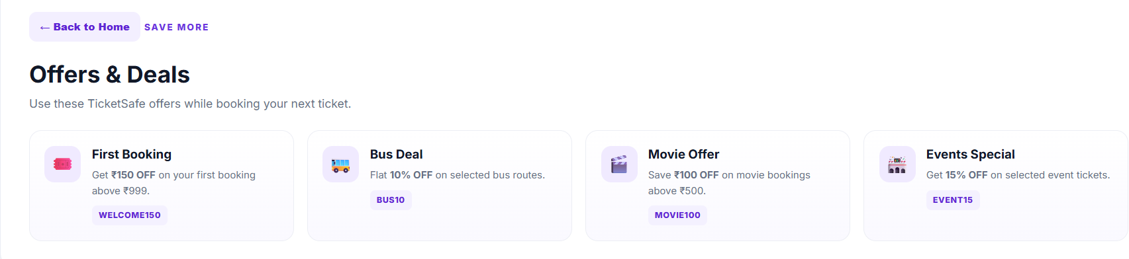
6.Help Center
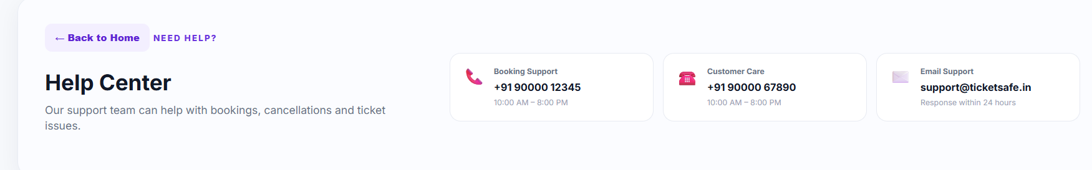

7.About us
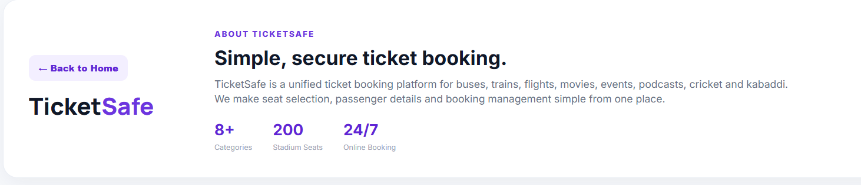
8.Pro Center
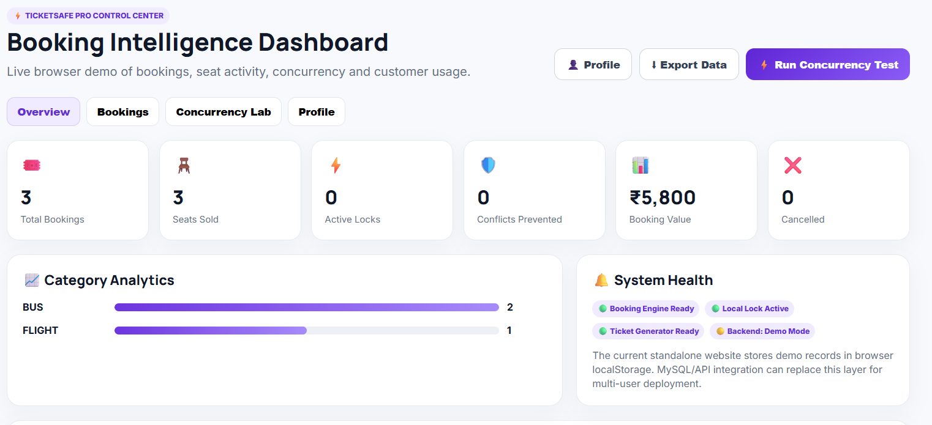
9. Notification Center
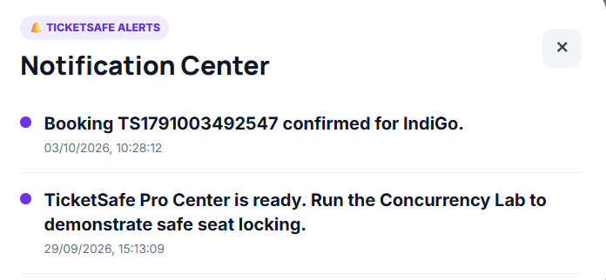
10.Passenger Details
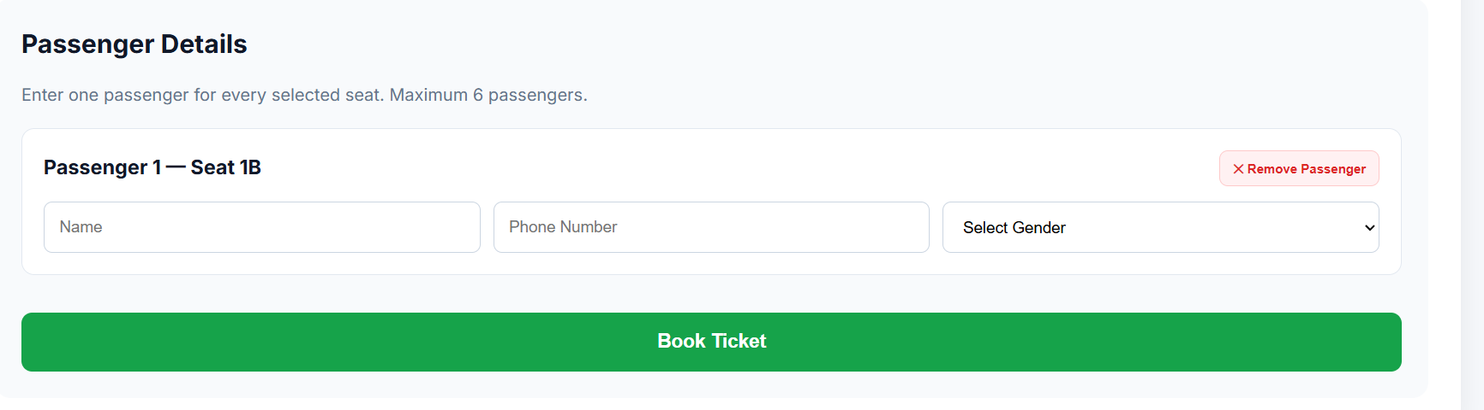
11.Booking Confirmed
